Important linux shortcuts

Ctrl+alt+T -> New Terminal Window
Ctrl+shift+T -> New Terminal Tab
Ctrl+shift+c -> Copy in Terminal
Crtl+Shift+V -> Paste in terminal
Ctrl+C -> Kill Current Command
~ -> Represents Home Directory
. -> Represents Current Directory
pwd -> Represents Current Directory
cd -> Change Directory
rm -> remove file
mkdir -> Create a folder
.filename -> . before filename represents its hidden file
ls -> lists files in the current directory
ls -l -> lists all files including hidden files
cd .. -> move back up to one directory level
cat filename -> display contents of filename
sudo apt-get install packagename -> Install the package in linux
sudo apt-get upgrade packagename -> Upgrades the package in linux
ps -> show current running process and their id
kill pid -> kill the process with the corressponding pid
command & -> adding & will push the current command running process to fg and let you use the same terminal window without having to open new terminal

Important Ros shortcuts

roscore -> Run the basic ros core files required to run other ros packages
rosrun package_name -> run ros packages directly
rosls -> list all contents of the ros package directory
roscd package_name -> change present directory to Ros package directory

(Do This always) Editing Bashrc to source setup.bash automatically

sudo nano ~/.bashrc
go to end of the file and add
source file_path (path of catkin setup.bash)
save file & log out and log in for changes to take effect
eg ~/catkin_ws/devel/setup.bash

(Fix rosed not working)

Make nano as editor for rosed command to edit ros package files on the go,
Add

export EDITOR='nano -w'

to ~/.bashrc file

NOTE: changes in .bashrc will only take effect for new terminals. Terminals that are already open will not see the new changes (eg. environmental variable).

Fixing rqt_graph not working (matplotlib error)

sudo apt-get install python
sudo apt-get install python-pip
python -m pip install -U pip
python -m pip install -U matplotlib
rosrun rqt_graph rqt_graph
Rosparam tutorial - get param from namespace ‘error parameter not set’
when creating a namespace to load the params using
rosparam load params.yaml copy_turtle
the params.yaml file is stored at /copy_turtle/params.yaml not /copy_turtle/turtlesim/params.yaml
So the code to retrive the parameters as shown is example is
rosparam get /copy_turtle/background_b where background_b is a parameter in params.yaml

Roslaunch tutorial (Launch file detailed explanation)
Mimic is a seperate node with subscription as /input/pose and and output topic as /output/cmd_vel .
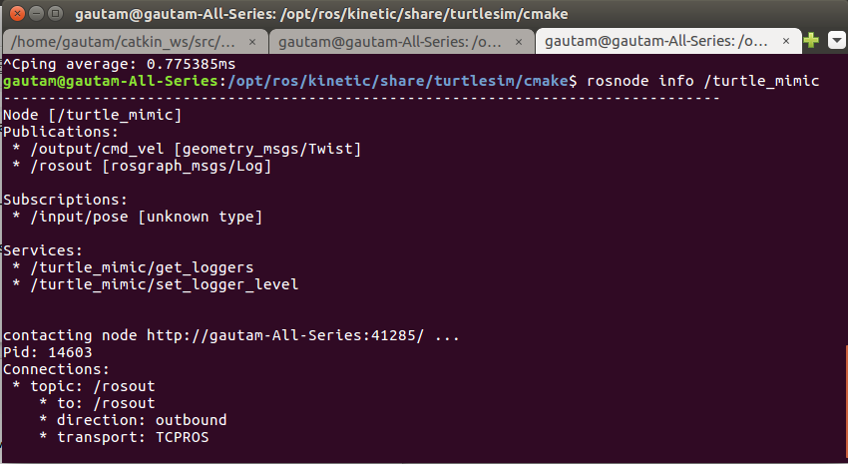
Turtlesim1 and turtlesim2 are in two seperate name spaces (environments / see different sets of resources).
When the turtlemimic.launch file launched using roslauch in beginner tutorials.
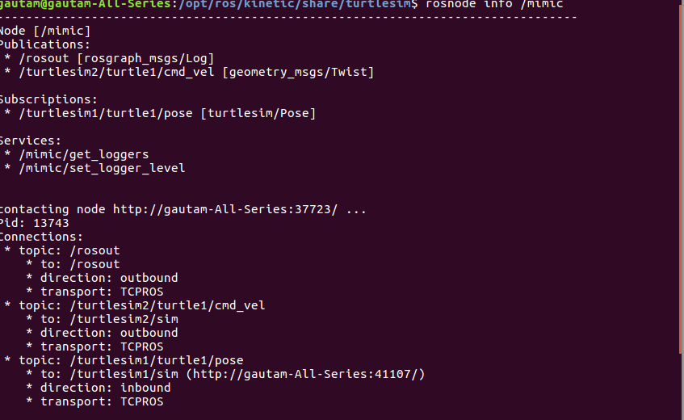
Input topic of mimic is remapped to turtlesim1/turtle1 from input (input/pose is replaced/renamed as turtlesim1/turtle1/pose)
similarly, output topic is renamed to turtlesim2/turtle1 from input ( output/cmd_vel is replaced/renamed as turtlesim2/turtle1/cmd_vel)
The bold text is alone renamed by the remap attribute in the launch file.
Creating a New Workspace and testing URDF
cd ~
mkdir ros_workspace
mkdir ros_workspace/src
cd ~/ros_workspace/src
catkin_init_workspace
cd ~/ros_workspace
catkin_make
Install Dependencies
cd ~/ros_workspace
rosdep install --from-paths src --ignore-src -r -y
catkin_make
Always source the /work_space/devel/setup.bash & setup.sh in /.bashrc.
Log Out and login again for changes to take effect
Now use roslaunch to test urdf and run roscore in seperate terminal window
URDF Info
Solidworks Axis
(SW) x=-y (ROS)
(SW) y=x (ROS)
Only change joint RPY
For key_teleop topic is key_vel in gazebo diff drive tag in urdf
For key_teleop_twist it is cmd_vel change in gazebo diff frive tag in urdf also
Change in launch file to launch the respective nodes is also required

